**Ghar Ka Khana**

By:

Vandan Mahendrakumar Pandya

(MSc.IT Semester VI)

2017-2018

**Exam No:**-

Guide name:- Mr Digvijay Virpura

Natubhai V. Patel College of Pure & Applied Sciences

Sardar Patel University

**Natubhai V. Patel College of Pure & Applied Sciences**

**CERTIFICATE**

Date:-

This is to certify that **Vandan Pandya** of M.Sc.IT-SEM-VI (seat no:- ) has worked on the project entitled **Ghar Ka Khana** (online tiffin delivery)from January-18 to February-18.This (PS06CIIT05) is in-house project course of three credits.

He was regular in his work and developed around 70 hours for the project including analysis and design. He has completed the project satisfactorily.

Ms Shreya Bhavsar Mr Digvijay Virpura

Head / Coordinator Project Guide

**Acknowledgement**

This project work has been the most practical and exciting part of my learning experience, which would be an asset for my future career.

No system is created entirely by an individual. Many people have helped me to create this system and each of their contribution has been valuable.

Proper organization of concept and analysis of the system is due to keen interest and helping hand of my teachers and colleagues.

I wish to place on my record my deep sense of gratitude to my project guide, **Mr Digvijay Virpura** for his constant motivation and valuable help through the project work.

Express my gratitude to our principal **Dr. Basudeb Bakshi** for molding my thoughts and vision towards all the subjects. I was studying till date.

I am also greatly thankful to the entire **Computer** **Science department** who have helped me in completion of this project directly or indirectly.

**INDEX**

|  |  |  |
| --- | --- | --- |
| Sr.No | Description of Topic | Page No |
| 1 | Introduction to the Project | 01 |
| 2 | Scope of Work | 02 |
| 3 | An Existing system | 03 |
| 4 | Need of proposed system | 04 |
| 5 | Feasibility study | 05 |
| 6 | System features | 07 |
| 7 | Hardware and Software requirements | 08 |
| 8 | Data flow diagram | 9-16 |
| 9 | Database layout | 17-19 |
| 10 | Design of input screens and output screens | 20-27 |
| 11 | Limitations | 28 |
| 12 | Conclusions | 29 |
| 13 | Bibliography | 30 |

**Introduction to the Project**

The project titled Ghar Ka Khana is Online tiffin delivery website for ordering tiffins. The project ***“*Ghar Ka Khana*”*** is developed in Asp.Net, which mainly focuses in providing tiffins to customers. This website has registeration form, login form, customer order form which helps in registeration and Ordering tiffins. From Admin panel admin can insert new meal. **“Ghar Ka Khana”** is a Website written in **Asp.net** designed to help customers.

Page no: 1

**Scope of Work**

Nowadays everyone is having busy schedule whether it is urban area or rural. But talking specifically about the urban areas and deeply about the big cities, people out there are so busy in their life that they don’t get enough of time to have their meals properly.

The online food ordering system provides the meal online and the customers can easily place the order by just clicking the mouse or by touching a button on their smart phones.

Therefore, this system enhances the speed of getting food in person’s plate and quality and manner of taking the order from the customer.

In this project we have developed something like the same to earn from and serve the nation in a much better way possible.

Page no: 2

**An Existing System**

In the present scenario people have to physically visit the hotels or restaurants for eating food, and have to make payment through cash mode most of the times due to unawareness of advanced technologies at certain places.

In this method time as well as physical work is required, among which time is something that no one has in ample amount. The traditional food ordering procedure is not efficient enough for hotels and restaurant, as they have to deal with crowd, in their restaurant.

The old methods can be classified into categories which are paper grounded and verbal grounded. For paper based work, the waiter comes and pens down foods that customers order and pass the food list containing paper to the chefs or cooks in the kitchen for further process.

Also from the owner’s point of view maintaining data record and the accounts in physical file is cumbersome and tedious work to do. And also it is full of risk as anyone can access it and modify the data.

Page no: 3

**Need of Proposed System**

This system is a bunch of benefits from various point of views. As this online application enables the end users to register to the system online, select the meal and order food online.

Also the payment can be made at the time of home delivery depending upon the customer’s choice and convenience.

Now person will assign the orders to the chef to be completed within a fixed duration of time.

As soon as the chef prepares the food, the later person forwards the parcels to the delivery persons assigned with the location and customer identity of the customer along with the bill status.

With this application the work load of the waiter in the hotels are reduced or in some situations the work is abolished.

One of the various benefits of this is system is that if there is rush or a huge crowd present in the restaurant then in that case sometimes unavailability of tables cut downs the restaurants customer.

This system allow the staff to serve customer within less time as compared to the manual system.

Page no: 4

**Feasibilty Study**

This is one of the main task of the developer to design a graphical user interface that user attracts to and can use easily, in one word it should be user friendly.

So for this you should have better understanding of customers likes and dislikes and the features that are in trend and mesmerize the public easily, initially we need to locate the targeting people that what kind of website do they need.

After getting all this information we should start to design the Website.

Page no: 5

**System Features**

This project aimed at developing an online food ordering system which can be used in small places, and medium cities firstly and then on a large scale.

It is developed to help restaurants to simplify their daily operational and managerial task as well as improve the dining experience of customers. And also helps restaurant develop healthy customer relationships by providing good services.

The system enables staff to let update and make changes to their food list information based on the orders placed and the orders completed.

Page no: 6

**Hardware Requirements:**

* **Processor:** Intel Pentium PIV 2.8 GHz Processor and Above or More
* **Ram:** 4 GB RAM
* **Hard Disk:** PC with 10-40 GB Space

**Software Requirements:**

* **Operating System Server:** Windows XP or later
* **Back End Tool:** Microsoft SQL Server-2008
* **Front End Tool :** Visual Basic 2010

Page no: 7

**DATA FLOW DIAGRAM**

The symbols used in DFD’s

1. Process:-

Here flow of data is transformed



1. External Entity:-

A source or destination of data which is external to the system.



1. A Data Flow:-

It is a packet of data. It may be in the form of a document, letter, telephone call etc.



Page no: 8

**Context Level Diagram**

**Ghar Ka Khana**

**Customer**

**Admin**

Page no: 9

**Zero Level Data Flow Diagram**

Response of Request

Request for Login

**Customer or Admin**

MMM

Page no: 10

**First level Data flow diagram**

Customer

Request for Information

Request for

Information

Information

Response of Information

**Cust_Registration**

Request for Information

Response of Information

**Cust_order**

Page no: 11

**First level Data flow diagram**

**Cust_Registration**

Admin

Request for Information

Request for

Information

Information

Response of Information

Request for Information

Response of Information

Request for Information

Response of Information

**Cust_order table**

**Tiffin table**

Page no: 12

**First level Data flow diagram**

Request for Information

Place Order

Response of Information

**Cust_order**

Page no: 13

**First level Data flow diagram**

Page no: 14

**Cust_regsiteration**

Create

Admin

Response of Information

Request for Information

**First level Data flow diagram**

Page no: 15

**Tifiin table**

Add

Tiffin

Response of Information

Request for Information

**First level Data flow diagram**

Page no: 16

**Cust _order**

Orders

Response of Information

Request for Information

**Database Layout**

**Cust_registeration**

|  |  |  |
| --- | --- | --- |
| **Column Name** | **Data Type** | **Size** |
| cust_id | numeric | 18 |
| cust_fname | Nvarchar | 50 |
| cust_lname | Nvarchar | 50 |
| cust_dob | Nvarchar | 50 |
| cust_phone | Nvarchar | 10 |
| cust_address | Nvarchar | 50 |
| cust_city | Nvarchar | 10 |
| cust_email | Nvarchar | 50 |
| cust_cpassword | Nvarchar | 50 |
| role | Nvarchar | 50 |

Page no:17

**Cust_order**

|  |  |  |
| --- | --- | --- |
| **Column Name** | **Data Type** | **Size** |
| order_id | Numeric | 18 |
| order_date | Nvarchar | 50 |
| order_type | Nvarchar | 50 |
| tiffin_items | Nvarchar | 50 |
| order_tiffins | Nvarchar | 50 |
| delivery_time | Nvarchar | 50 |
| total | Nvarchar | 50 |
| cust_name | Nvarchar | 50 |
| cust_phone | Nvarchar | 50 |
| Cust_email | Nvarchar | 50 |

Page no: 18

**Tiffin**

|  |  |  |
| --- | --- | --- |
| **Column Name** | **Data Type** | **Size** |
| tiffin_id | Numeric | 18 |
| tiffin_type | Nvarchar | 50 |
| tiffin_items | Nvarchar | 50 |
| tiffin_price | Nvarchar | 50 |

Page no: 19

**Design of Input/output screens**

**Home page**

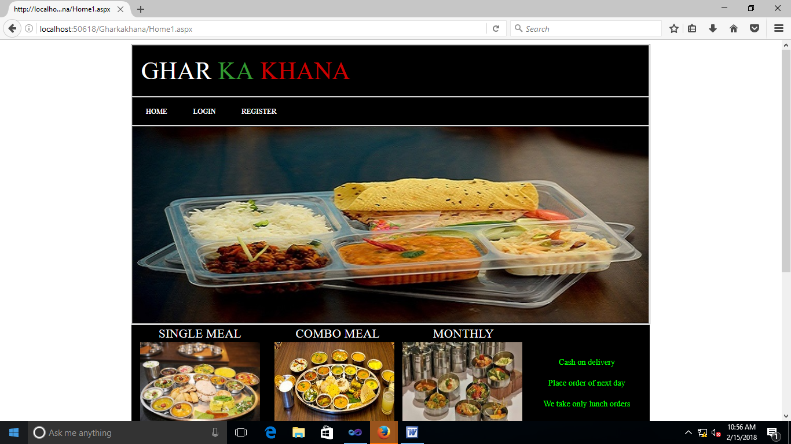

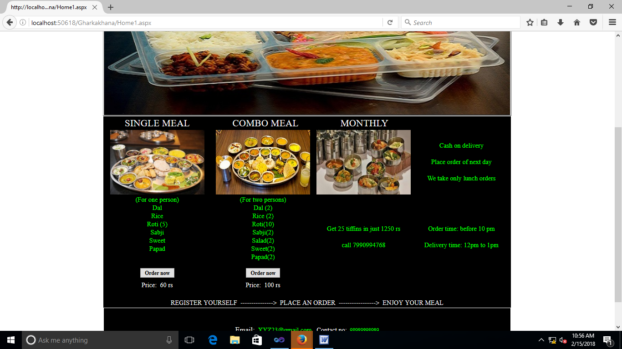

Page no: 20

**Login page**

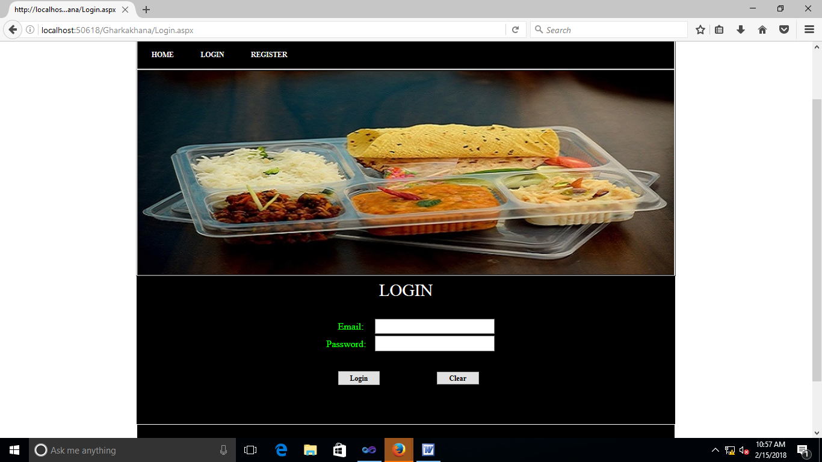

Page no: 21

**Customer Registeration page**

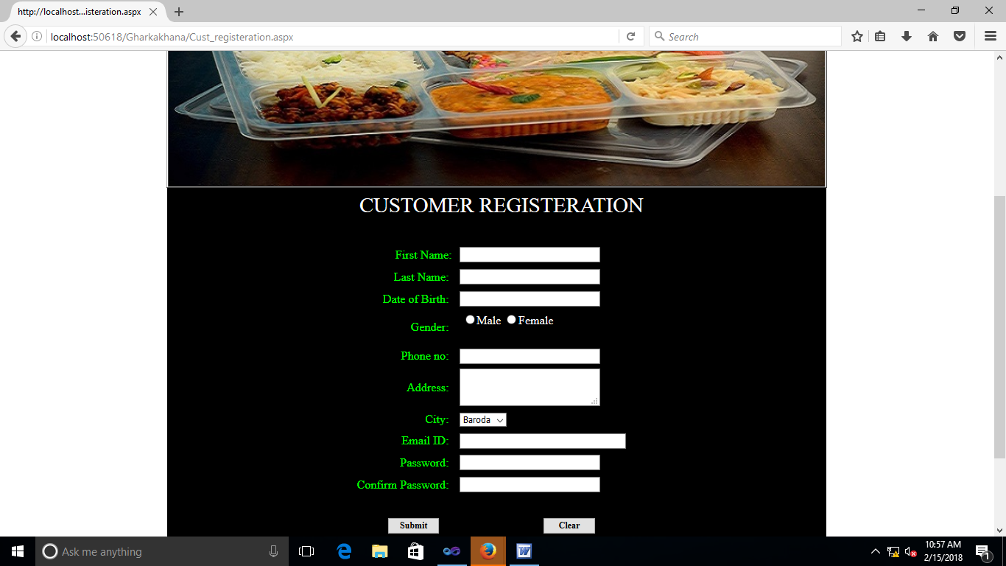

Page no: 22

**Customer Registeration page**

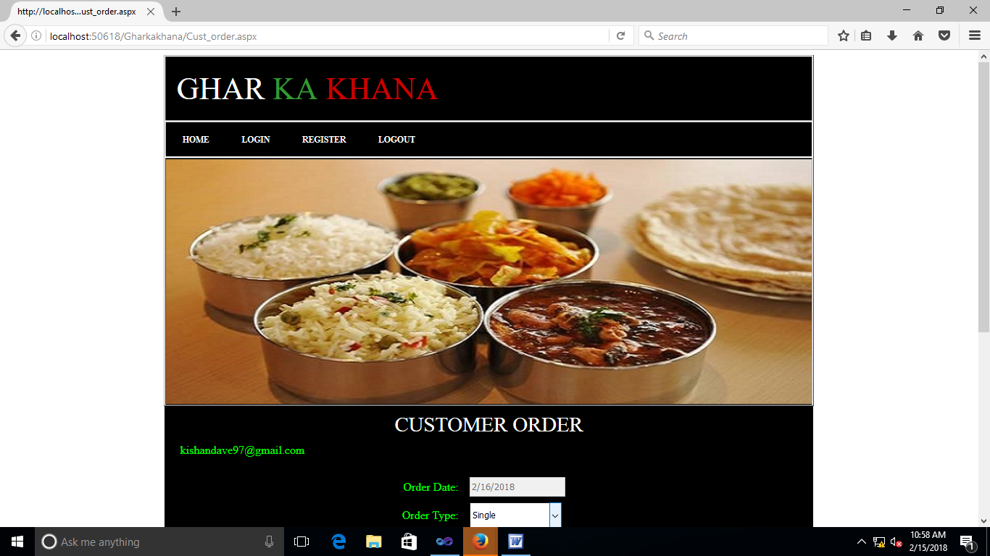

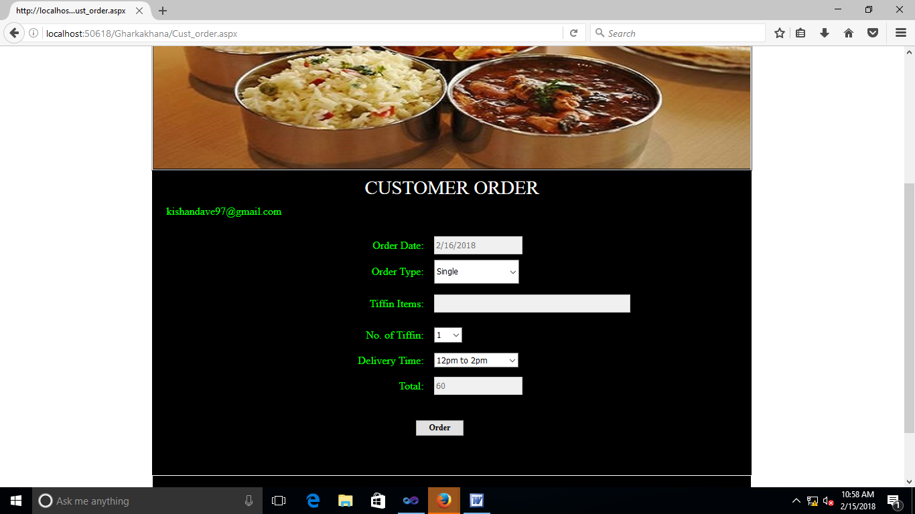

Page no: 23

**Admin Registeration page**

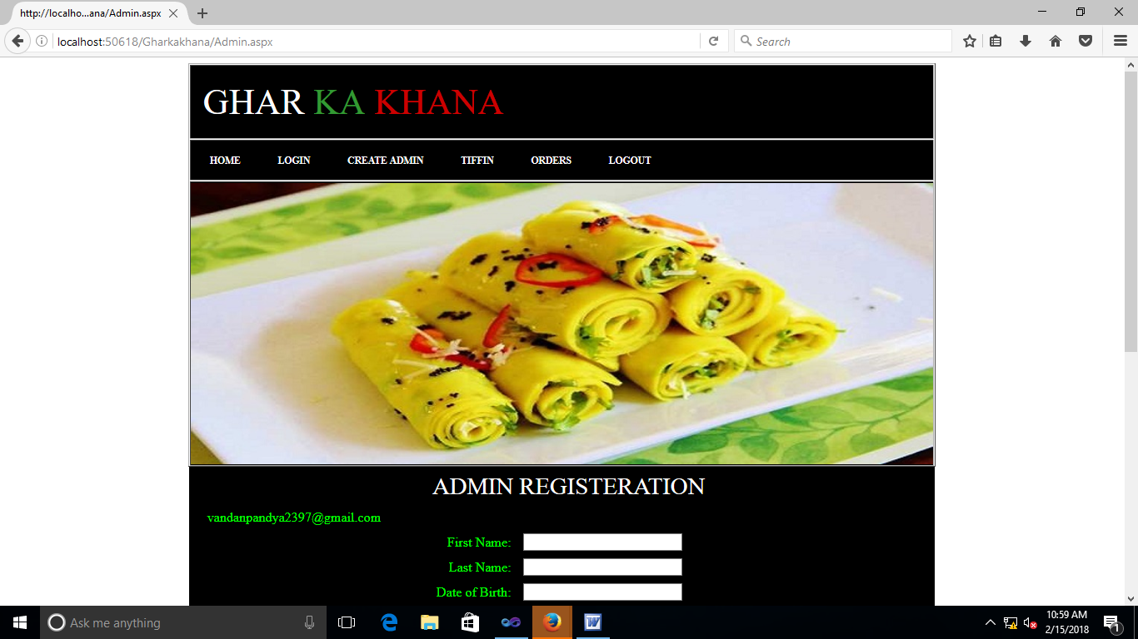

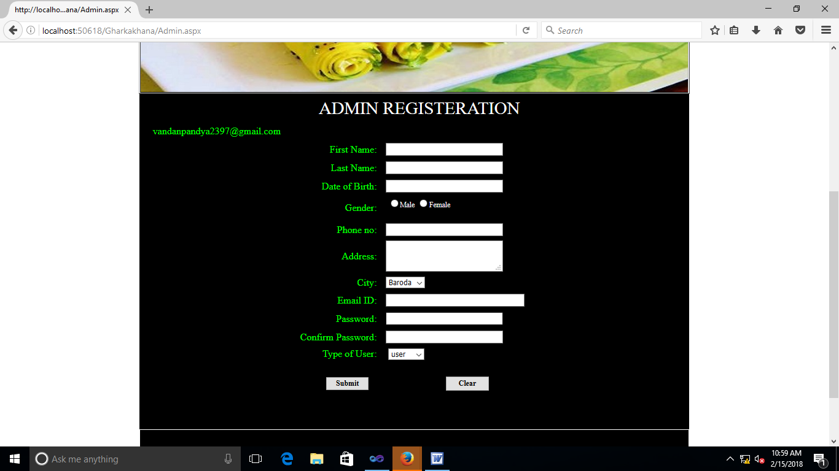

Page no: 24

**Add Tiffin page**

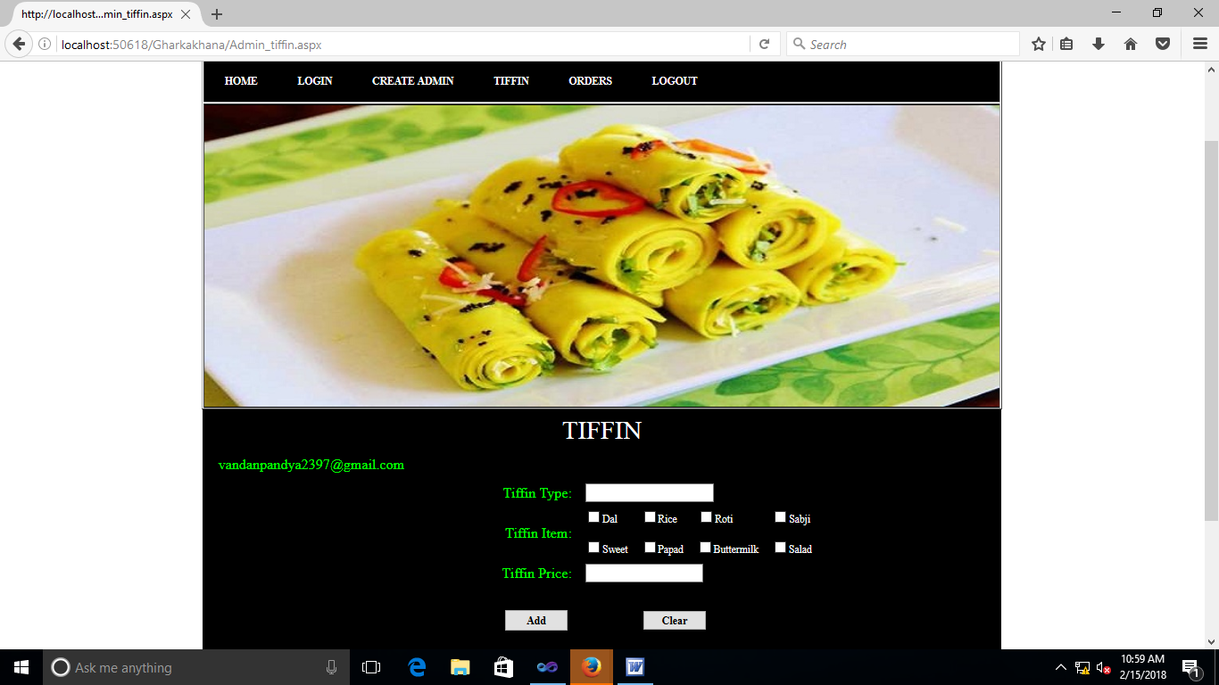

Page no: 25

**Orders page**

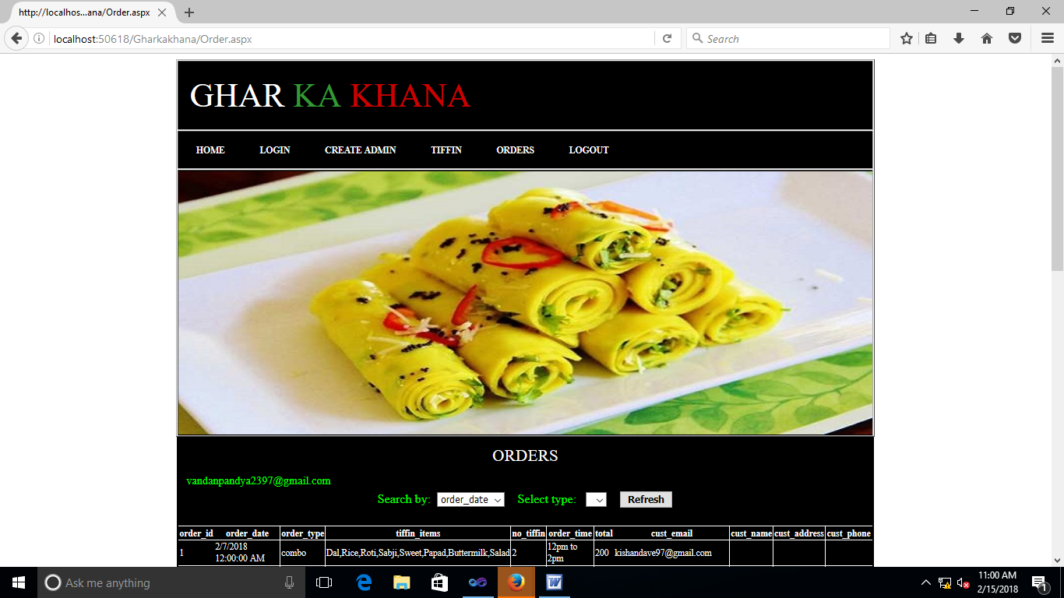

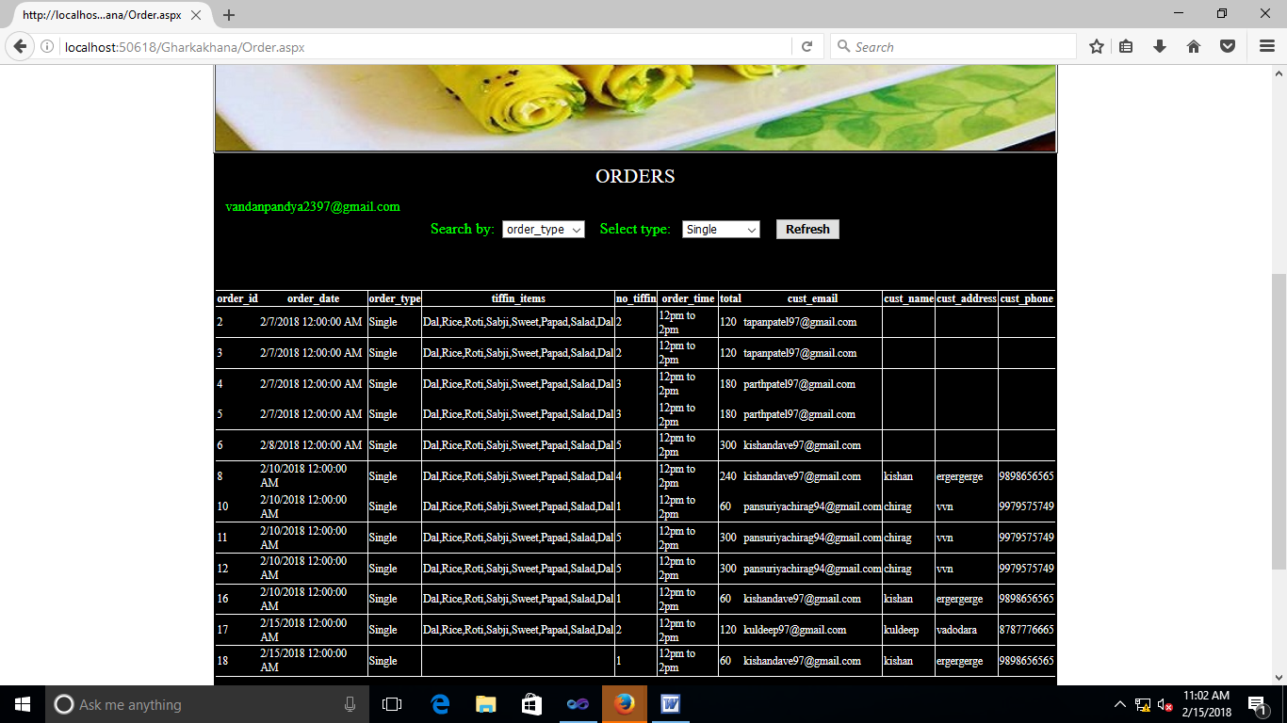

Page no: 26

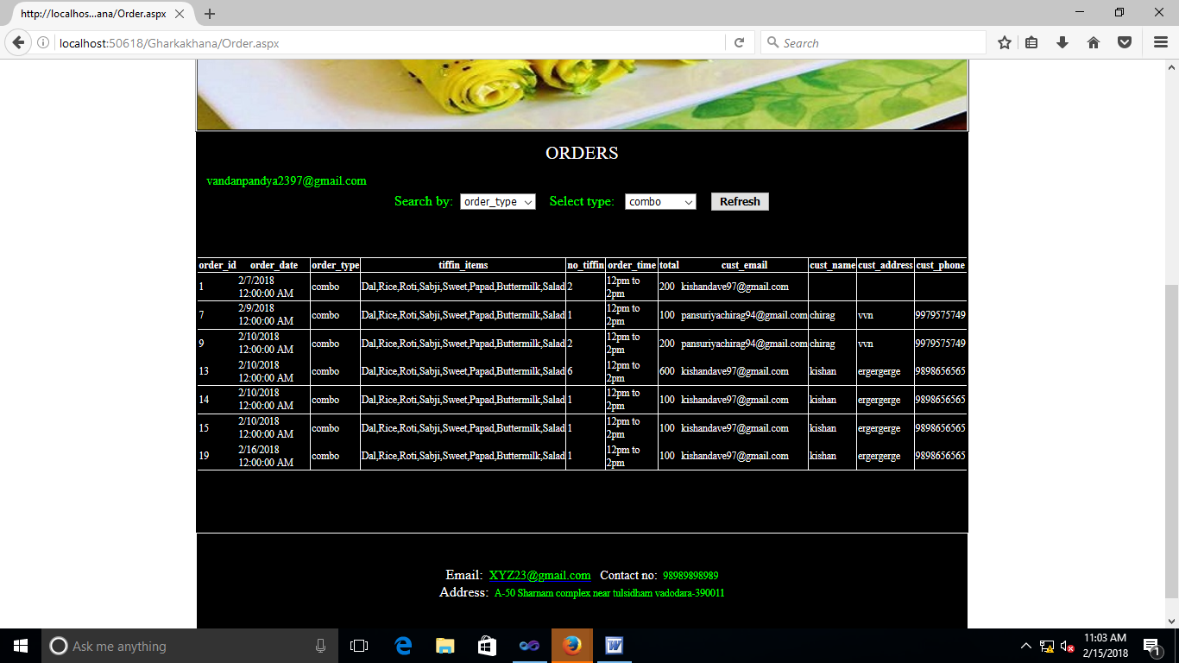

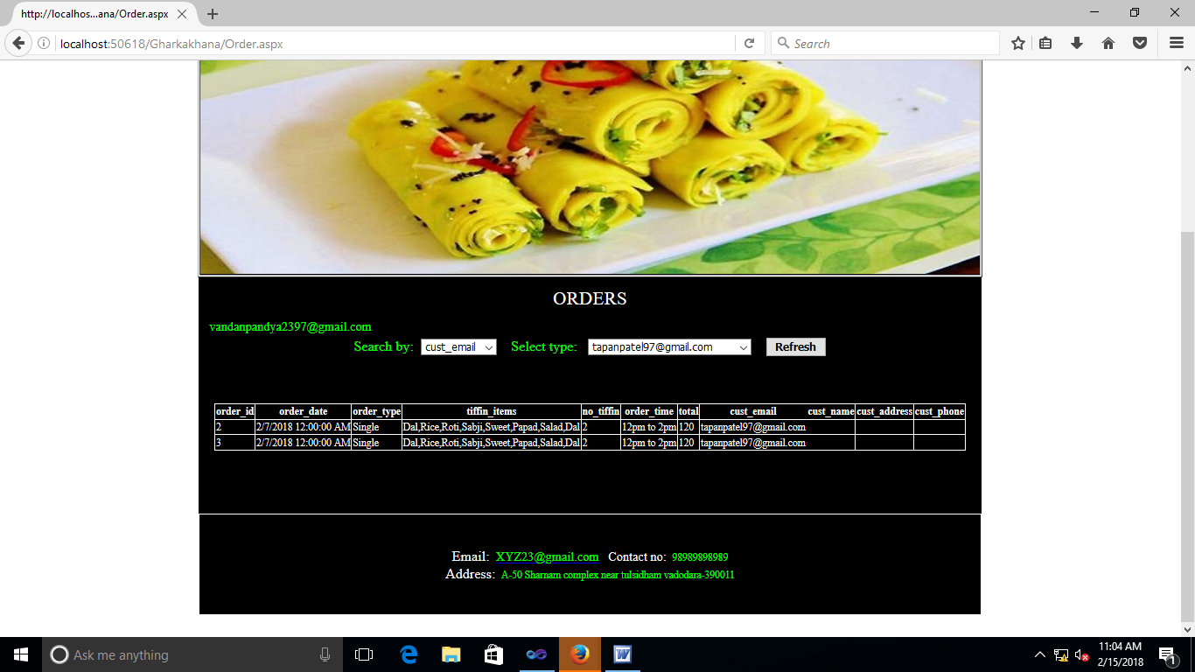

Page no: 27

**Limitations**

This project ”Ghar Ka Khana” do not satisfy the each and every need of the online tiffin delivery system so it does has some limitations through which one would like to know that how a project is going to work upon its features.

1. Customer can’t order tiffin for multiple days but he can order tiffin of next day.
2. Customer has to order his tiffin a day before he wants the tiffin.
3. Customer cant choose items in tiffin, but he has variety of meals to choose.
4. Tiffin cannot be tracked.
5. Customer can order tiffin till 12am , after that he can’t order.

Page no: 28

**Conclusion**

* The online food ordering system provides the meal online and the customers can easily place the order by just clicking the mouse or by touching a button on their smart phones.
* Therefore, this system enhances the speed of getting food in person’s plate and quality and manner of taking the order from the customer.
* In this project we have developed something like the same to earn from and serve the nation in a much better way possible.

Page no: 29

**Bibliography**

* **WEBSITE:-**
* [http://www.google.com](http://www.google.com/)
* [http://www.codeproject.com](http://www.codeproject.com/)
* <http://www.vbcode.com>
* http://www.w3schools.com
* **BOOKS:-**
* Asp.Net Black Book
* **HELP:-**
  + - * Mr Digvijay Virpura
      * Mr Chirag Pansariya

Page no: 30